#1 – FileZilla folders have been set up and have the necessary content in them.

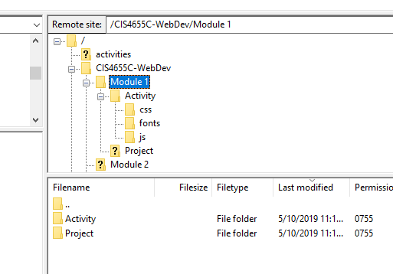

#2 – Visual Studio Code will be my editor. Folders have been set up.

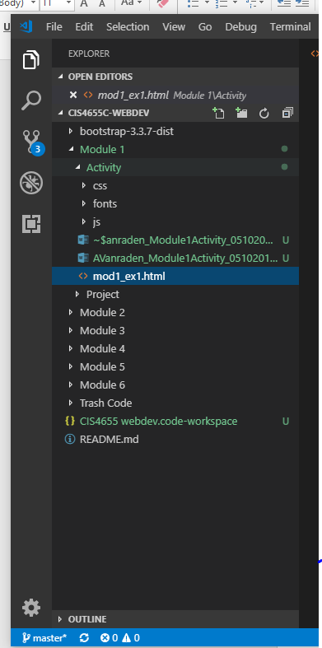

#3 – URL to the Hello World page.

<http://sotd.us/austinvanraden/CIS4655C-WebDev/Module%201/Activity/mod1_ex1.html>

#4 – Hello World Webpage

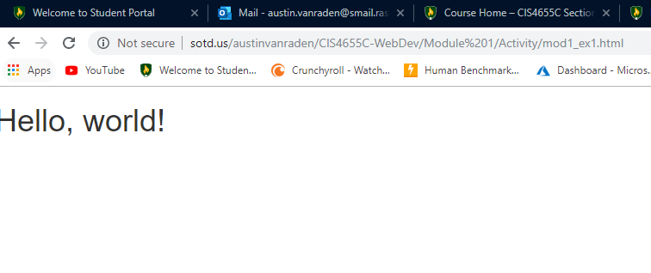

#5 – Github account URL

<https://github.com/AustinVanStroodleBerry/CIS4655C-WebDev>